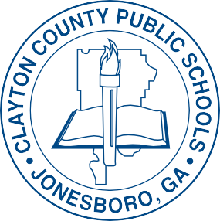
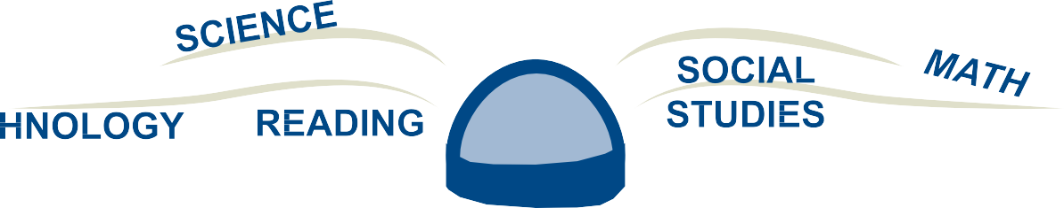
"COMMITTED TO HIGH PERFORMANCE"

CLAYTON COUNTY PUBLIC SCHOOLS
EMPOWERING PARENTS TO GET ENGAGED AND STAY INVOLVED

TITLE I PARENT ACADE Y

SATURDAY NOVEMBER 2, 2019
9:00 A.M. - 12:00 P.M.
(ALL PARENTS & GUARDIANS ARE WELCOME TO ATTEND)

Mt. Zion High School 2535 Mt. Zion Parkway
Jonesboro, Georgia 30236

EXCITING AND ENGAGING ACADEMIC WORKSHOPS WILL BE OFFERED TO ALL ATTENDEES.

PARENTS WILL ALSO HAVE AN OPPORTUNITY TO RECEIVE RESOURCES FROM COMMUNITY VENDORS.

FOR MORE INFORMATION PLEASE CONTACT
THE OFF CE OF FEDERAL PROGRAMS@ (770) 473-2700

