Comprehensive School Improvement Plan

Pointe South Middle School

2019-2020

Vision Statement
The vision of Clayton County Public Schools is to be a district of high performance ALL students
to live and compete successfully in a global society.

Mission Statement
The mission of Clayton County Public Schools is to empower students to achieve academic and personal goals.

Principal: Kimberly Grant

Assistant Principal(s): Corey Stephens

School Leadership/Improvement Team
Name | Position
Vacant | Instructional Facilitator
Lydia McKeever | Media Specialist
Janaia Bailey | Lead Counselor
Kimberly Jenkins | Grade Level Chairperson
Kimberly Lawson-Powell | ELA Department/Grade Level Chairperson
Onequa Hampshire | Math Department Chair
Kurt Harden | Science Department Chair
Evander Rhea | Social Studies Department Chair
Kenya Cooper | DES Department Chair
Gwendolyn Smith | Connections Department Chair
Brian Baker | Athletic Director
Taji McCall | Parent & Community Liaison
Kyra Maxwell | Grade Level Chairperson
Carlethia Wharton | Math Intervention Specialist

CCRPI Score
2015-2016 | 2016-2017 | 2017-2019 | 2018-2019 | 2016-2020 Goals
Overall CCRPI Score:  59.6 | Overall CCRPI Score:  59.9 | Overall CCRPI Score:  54.6 | Overall CCRPI Score: | 2016 Goal: 57.223 2019 Goal: 61.192  2017 Goal: 58.546 2020 Goal: 62.515  2018 Goal: 59.869  Overall CCRPI Goals based on the following formula:  CCPRI Performance Goals  For each year during the five-year Strategic Waiver School System term, formerly the Investing in Educational Excellence (IE2), with the baseline year 2014-2015, Pointe South Middle School will increase its College and Career Ready Performance Index (CCRPI) score with Challenge Points by 3% of the gap between the baseline year CCRPI score and 100.  $$IE2 Annual Growth=\left(100-2015 CCRPI Score \left(without Challenge Points\right)\right)×0.03$$  Example  Baseline CCRPI Score Expected Annual Growth Year 1 Year 2 Year 3 Year 4 Year 5  55.9 (100 – 55.9)(.03) 55.9 + 1(1.323) 55.9 + 2(1.323) 55.9 + 3(1.323) 55.9 + 4(1.323) 55.9 + 5(1.323)  1.323 57.223 58.546 59.869 61.192 62.515
Achievement Points Earned: 21.1/50 | Achievement Points Earned: 20.7/50 | Achievement Points Earned: 11/30 | Content Mastery Points Earned:  /30
Progress Points Earned: 32.7/40 | Progress Points Earned: 32.0/40 | Progress Points Earned: 22.6/35 | Progress Points Earned:  /35
Achievement Gap Points Earned: 5.8/10 | Achievement Gap Points Earned: 6.7/10 | Achievement Gap Points Earned: 6.57/15 | Closing Gaps Points Earned:  /15
Challenge Points Earned: 0.5/10 | Challenge Points Earned: 0.5/10 | Readiness Points  Earned: 14.4/20 | Readiness Points Earned  /20

Pointe South Middle School Data Profile

School Demographic Data
 | 2017-2018 | 2018-2019 | 2019-2020
Total Enrollment | 854 | 823 | 870
Asian | 5 | 3 | 4
Black | 673 | 655 | 670
Hispanic | 140 | 134 | 152
Multiracial | 22 | 23 | 30
White | 13 | 8 | 12
English Language Learners | 18 | 19 | 34
Gifted | 23 | 17 | 20
Students with Disabilities | 118 | 92 | 117

Intervention Data

iReady

School Year | Percentage of students at or above Grade Level  Beginning of Program | Percentage of students at or above Grade Level  Middle of Program | Percentage of Students who achieved Target Growth
2017-18 | NA | Math: 6.6%  Reading: 11.6% | Math: 35% (749 Students)  Reading: 40% (714 Students)
2018-19 | NYA | NYA | NYA
2019-2020

Language Live

School Year | BOY | MOY | EOY
2016-17 | 584 | 649 | 647
2017-18 | 605 | 635 | 699.6

2018-19

2019-2020

Math180

School Year | BOY | EOY | Growth %
2016-17 | I: 468  II: 450 | I: 505  II: 554 | I: 7.3% (37)  II: 18.9% (105)
2017-18 | I: 524  II: 529 | I: 651  II: 607 | I: 19.5% (127)  II: 12.8% (78)
2018-19 | 580 | 600 | 680

2019-2020

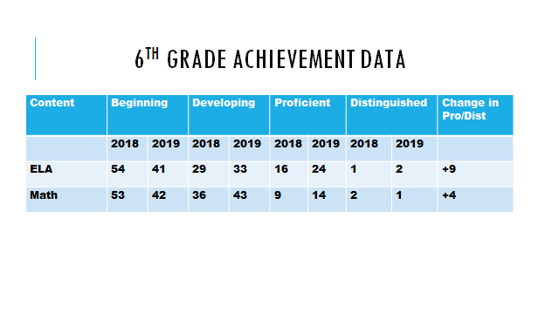

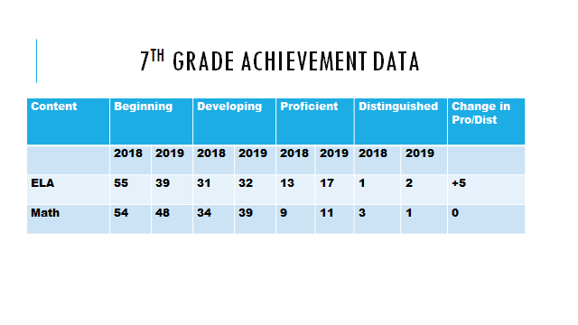
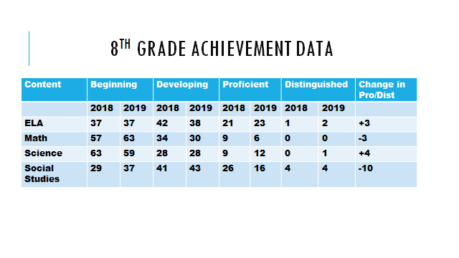
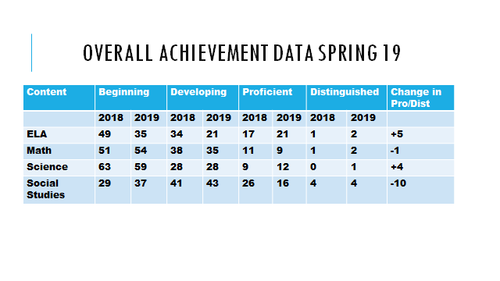
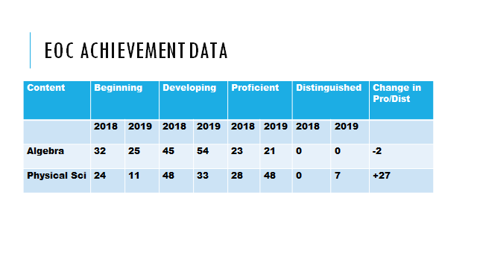
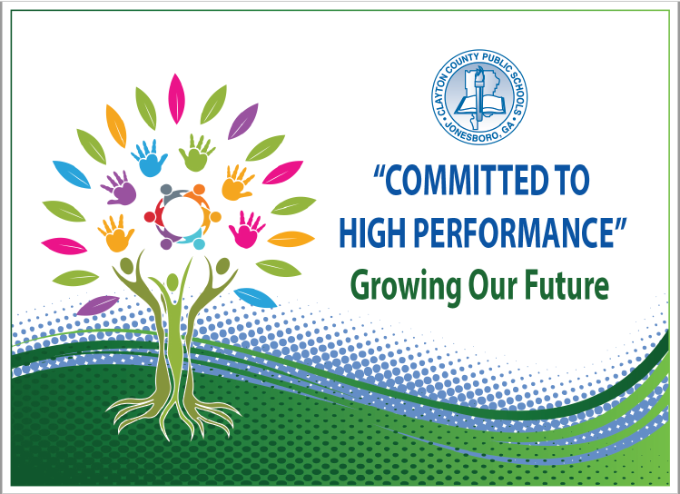
Strategic Goals
To increase academic achievement for all students in Clayton County Public Schools as evidenced by state, national, and international assessment results
To provide and maintain a safe and orderly learning environment
To create an environment that promotes active engagement, communication, accountability, and collaboration of all stakeholders to maximize student achievement
To provide high quality support services delivered on time and within budget to promote high performance in the Clayton County Public Schools
To recruit, develop, and retain highly qualified and effective staff

Action Plan

Performance Objective 1: By 2023, Clayton County Public Schools will increase the percentage of student scoring at the Proficient and/or Distinguished levels on the Georgia Milestones to at least 80% in each content area.
GADOE School Improvement Systems: Coherent Instruction, Effective Leadership, Family and Community Engagement, Professional Capacity
Action Steps/ Tasks | Timeline | Project Leader(s) and School Level Person(s) Monitoring | Resources/ Funding | Check Points/ Related Artifacts and Evidence | Professional Learning  Activity and Date  (where applicable)
- Maintain and increase effectiveness of Collaborative Planning | Weekly  August 2019  To  May – 2020 | Academic Coach  Administrative Team | - Title I  - Rigor & Relevance Tool Kit | - Academic Framework Lesson plan template  - Agenda  - Sign-In Sheet  - Observation | All Tuesdays ELA & SS  All Wednesdays Math & Science
- Academic Coach and/or external vendors will conduct micro professional development sessions on select instructional strategies during common planning. | Monthly  August 2019  To  May – 2020 | Administration | - Title I  - Rigor & Relevance Tool Kit | - Lesson plan template  - Agenda  - Sign-In Sheet | - Close Read Strategies in all Content Areas September 2019  - Differentiated Instruction September 2019  - Additional Sessions as needed
- Administrators and Academic Coach will attend collaborative planning session. Teachers will complete planning notes document and upload to the PSMS FY20 Google Drive folder. Academic coach will lead collaborative/data planning weekly on Tuesday/Wednesday during 70 minute blocks. | Weekly  August 2019  To  May – 2020 | Administration  Academic Coach  Instructional Leads  Teachers | Title I | - School wide collaborative planning calendar will list a timeline for planning activities  - Collaborative agendas will be maintained on Google Drive and in the instruction planning room  - Sign-in forms will indicate teachers who are present for each sessions  - Administrators will monitor collaborative planning as well as attend each collaborative planning session  - Administrators will monitor, review, and provide feedback to all data activities | Collaborative Planning Assistance as needed
- Implement problem based learning for all grade levels (CER/ADI will be implement as an alternative) | Ongoing  September 2019  To  May – 2020 | Administration  Academic Coach  Instructional Leads  Teachers | Title I  Professional Learning | - Initial observations of PBL will take place in the month of September 2019 by administration and academic coach  - PBL activities will be noted in lesson plans as well as on daily instructional agendas  - Teachers will maintain evidence of professional learning in data notebook | PBL training September  PBL individual assistance - ongoing
- Grade Level/Content Chairpersons will development a data analysis calendar based on school based and district common assessments. | August 2019  To  May – 2020 | Leadership Team  Title I Academic Coach  Department Chairpersons | - Title I  - Rigor & Relevance Tool Kit | - Academic Framework Lesson plan template  - Agenda  - Sign-In Sheet | N/A
- Teachers will administer mini assessments weekly to determine student mastery of targeted standard. Teachers will evaluate data monthly and adjust monthly focus plan when necessary. | Upon completion of units or sections of unit (See departmental calendar) | Administration  Academic Coach  Teachers  Media Specialist | N/A | - Department and Master assessment calendars will be posted on Google Drive as well as room 303  - Data Talk documents will detail results of assessments and next steps | New Teachers will be trained to analyze data in September 2019
- Administration will conduct informal walkthroughs (Caught Implementing Rigor and Relevance – CIRR), TKES walkthrough, and Formative Evaluations to ensure implementation of CER instructional strategies. | Ongoing (daily)  September 2019  To  May 2020 | Administration  Teachers  Media Specialist  Media Clerk | N/A | Individual teacher CIRR calendars will indicate monthly dates that rigor and relevance were observed by administration | N/A

Supplemental Supports: What supplemental action steps will be implemented for these subgroups?
Economically Disadvantaged | Foster and Homeless
After/Before school and Saturday tutorials will take place on a regular basis to address the needs of economically disadvantaged students. Paraprofessional and teachers tutors will conduct push in and pull outs to address student deficits. Students will be provided with necessary supplies as determined by teacher. Additionally, school staff will provide instructional support within local neighborhoods to ensure all students have access to instructional support | Counselors, social worker, parent liaison, etc. will connect students to school based and community support systems to ensure the needs of the child and family are met. Present courses in multiple formats (i.e. online) so that students who are mobile have the opportunity to graduate on time.
English Learners | Migrant
ELL teachers will provide additional assistance to EL students by affording students opportunities to work with manipulatives and translation devices to support core content. The media specialist will provide student access to content specific supplemental material. | Counselors, social worker, parent liaison, etc. will connect students to school based and community support systems to ensure the needs of the child and family are met. Pair students with a buddy who is/has been a migrant student until student is acclimated to the school.
Race/Ethnicity/Minority | Students with Disabilities
After/Before school and Saturday tutorials will take place on a regular basis to address the needs of economically disadvantaged students. Paraprofessionals, teachers and volunteer tutors will conduct push in and pull outs to address student deficits. | After/Before school and Saturday tutorials will take place on a regular basis to address the specific needs of students with disabilities. Paraprofessionals, Teachers and volunteer tutors will conduct push in and pull outs to address student deficits. Lessons will be differentiated to support each student’s IEP and 504 accommodations.

Performance Objective 2: Over the next five years, Clayton County Public Schools will increase the graduation rate from 69.6% to 90% or higher.
GADOE School Improvement Systems: Coherent Instruction, Effective Leadership, Family and Community Engagement, Professional Capacity
Action Steps/ Tasks | Timeline | Project Leader(s) and School Level Person(s) Monitoring | Resources/ Funding | Check Points/ Related Artifacts and Evidence | Professional Learning  Activity and Date  (where applicable)
- The student support team will identify and meet with each retained student to develop a plan to recover credits to ensure students are successful and continue to move with their respective cohort.  - Counselors will identify retained students  - Counselors will pull transcripts and credit summaries of retained students  - SST chairperson will review transcript with student and/or parent and develop a plan to recover credits/  - SST chairperson, counselors and administrators will monitor student progress of steps in the plan.  - SST chairperson, counselors and administrators will meet with parents and student on an ongoing basis. | September 2019 - May 2020 | Administration  SST Chair  Counselors  Teachers | Title I | - SST chairperson will meet with targeted student at the end of first semester to review grades.  - Academic plans for each student will be maintained in the counselor’s suite and monitored by SST chairperson.  - Parent and student contact logs will be maintained in Infinite Campus. | N/A
- Counselors, teachers and administration will monitor student data of 6th and 7th grade students to ensure all students in FY21 enter high school with high school credit(s). | Ongoing | Administration  Counselors  6th and 7th Grade Teachers | - Title I  - General Funds | - Assessment Data: GMAS, Lexile Level, Common Assessments, IReady  - Monthly Data Analysis with instructional Coach | N/A
- Monitor student grades to select students to participate in target tutorials after school and on weekends. | August – 2019  To  May – 2020 | Administration  Counselors  All Teachers | - Title I  - General Funds | - Monthly Principal Data Collection and verification checklist  - Weekly Error Report checks through Infinite Campus  - FTE Verification October and April | TBD District FTE Training Sessions  TBD: Year-End Meeting

Supplemental Supports: What supplemental action steps will be implemented for these subgroups?
Economically Disadvantaged | Foster and Homeless
After/Before school and Saturday tutorials will take place on a regular basis to address the needs of economically disadvantaged students. Paraprofessional and teachers tutors will conduct push in and pull outs to address student deficits. Students will be provided with necessary supplies as determined by teacher. Additionally, school staff will provide instructional support within local neighborhoods to ensure all students have access to instructional support | Counselors, social worker, parent liaison, etc. will connect students to school based and community support systems to ensure the needs of the child and family are met. Present courses in multiple formats (i.e. online) so that students who are mobile have the opportunity to graduate on time.
English Learners | Migrant
ELL teachers will provide additional assistance to EL students by affording students opportunities to work with manipulatives and translation devices to support core content. The media specialist will provide student access to content specific supplemental material. | Counselors, social worker, parent liaison, etc. will connect students to school based and community support systems to ensure the needs of the child and family are met. Pair students with a buddy who is/has been a migrant student until student is acclimated to the school.
Race/Ethnicity/Minority | Students with Disabilities
After/Before school and Saturday tutorials will take place on a regular basis to address the needs of economically disadvantaged students. Paraprofessionals, teachers and volunteer tutors will conduct push in and pull outs to address student deficits. | After/Before school and Saturday tutorials will take place on a regular basis to address the specific needs of students with disabilities. Paraprofessionals, Teachers and volunteer tutors will conduct push in and pull outs to address student deficits. Lessons will be differentiated to support each student’s IEP and 504 accommodations.

Performance Objective 3: By 2023, Clayton County Public Schools will increase the number of students absent less than 10% of their enrolled academic year.
GADOE School Improvement Systems: Effective Leadership, Supportive Learning Environment, Family and Community Engagement, Professional Capacity
Action Steps/ Tasks | Timeline | Project Leader(s) and School Level Person(s) Monitoring | Resources/ Funding | Check Points/ Related Artifacts and Evidence | Professional Learning  Activity and Date  (where applicable)
- The attendance support team will monitor student attendance to identify students with at risk attendance. Counselors and social workers will meet with parents to develop an action plan to improve attendance. | Ongoing | Administration  Counselors  Social Worker  Attendance Clerk  Teachers | Local Budget | Administrators will review attendance weekly.  Attendance Sppport Team will be reviewed monthly.  Attendance Focus Group agenda, action plans and meeting notes will be maintained on Google Drive. | N/A
- PSMS will follow the CCPS district protocols for attendance. | Ongoing | Administration  Counselors  Social Worker  Attendance Clerk  Teachers | Local Budget | Parents will be contacted when absent 3 days or more.  Teachers will maintain a contact log and document in Infinite Campus Documents for compliance to district attendance protocols will be maintained in the attendance office. | N/A
- PSMS will implement a student recognition program for students with perfect attendance as well as the grade level with the highest attendance each month, | Ongoing  Monthly Recognition | Administration  Counselors  Social Worker  Attendance Clerk  Teachers | Local Budget | The attendance support team will meet monthly to determine grade level and students to receive recognition.  Documentation of students who are recognized will be maintained in the Google Drive. | N/A

Supplemental Supports: What supplemental action steps will be implemented for these subgroups?
Economically Disadvantaged | Foster and Homeless
After/Before school and Saturday tutorials will take place on a regular basis to address the needs of economically disadvantaged students. Paraprofessional and teachers tutors will conduct push in and pull outs to address student deficits. Students will be provided with necessary supplies as determined by teacher. Additionally, school staff will provide instructional support within local neighborhoods to ensure all students have access to instructional support | Counselors, social worker, parent liaison, etc. will connect students to school based and community support systems to ensure the needs of the child and family are met. Present courses in multiple formats (i.e. online) so that students who are mobile have the opportunity to graduate on time.
English Learners | Migrant
ELL teachers will provide additional assistance to EL students by affording students opportunities to work with manipulatives and translation devices to support core content. The media specialist will provide student access to content specific supplemental material. | Counselors, social worker, parent liaison, etc. will connect students to school based and community support systems to ensure the needs of the child and family are met. Pair students with a buddy who is/has been a migrant student until student is acclimated to the school.
Race/Ethnicity/Minority | Students with Disabilities
After/Before school and Saturday tutorials will take place on a regular basis to address the needs of economically disadvantaged students. Paraprofessionals, teachers and volunteer tutors will conduct push in and pull outs to address student deficits. | After/Before school and Saturday tutorials will take place on a regular basis to address the specific needs of students with disabilities. Paraprofessionals, Teachers and volunteer tutors will conduct push in and pull outs to address student deficits. Lessons will be differentiated to support each student’s IEP and 504 accommodations.

Performance Objective 4: By 2023, Clayton County Public Schools will decrease the number of discipline infractions while increasing employee morale and community support.
GADOE School Improvement Systems: Effective Leadership, Supportive Learning Environment, Family and Community Engagement, Professional Capacity
Action Steps/ Tasks | Timeline | Project Leader(s) and School Level Person(s) Monitoring | Resources/ Funding | Check Points/ Related Artifacts and Evidence | Professional Learning  Activity and Date  (where applicable)
Implement PBIS Behavior Management improvement process | August – 2019  To  May – 2020 | Leadership Team  Counselors  All Teachers | - Title I  - General Funds  - PBIS Funding | - Monthly review of academic, discipline, and attendance data  - PBIS committee will review surveys related to safety, climate, and culture  - Meeting Agendas  - Sign-in Sheets  - PBIS Data Review Sessions  - District Level Training Materials | PBIS Coaches Training:  PBIS Staff Training  Additional District PBIS Training
Re-establish Circle of Support to provide guidance | September 2019 – May 2020 | Administration  Counselors  Teachers  Behavior Specialist  Social Worker | - General | - Monthly review of academic, discipline, and attendance data of identified students. | N/A
Students will participate in mediation sessions to prevent altercation. Students will be taught strategies to deescalate discourse. | August 2019 – May 2020 | Administration  Counselors  Social Worker | - General | - Sign-in Forms  - No harm Agreements  - Safety Assessment Forms | N/A
PSMS will incorporate a recognition program for students who display positive behavior. | Monthly August 2019 – May 2020 | Administration  Teachers  Parent Liaison | Local School Budget | PSMS will recognize the students of the month for each grade level to reward and honor those students for demonstrating excellence in the school. Artifacts will consists of certificates, pictures, video on the school‘s web page, and recognition in the classroom. | N/A
PSMS counselors will develop social skills lessons and advising sessions which will be presented monthly during the 1st 30 minutes of the instructional focus plan | September 2019 – May 2020 | Administration  Teachers  Counselors  Social Worker | Local School Budget | PSMS will begin teaching social skills in each non-tested social studies classroom using the Boys Town Model. Artifacts will include detailed lesson plans. | Counselors will train staff prior to social skills courses.

Supplemental Supports: What supplemental action steps will be implemented for these subgroups?
Economically Disadvantaged | Foster and Homeless
After/Before school and Saturday tutorials will take place on a regular basis to address the needs of economically disadvantaged students. Paraprofessional and teachers tutors will conduct push in and pull outs to address student deficits. Students will be provided with necessary supplies as determined by teacher. Additionally, school staff will provide instructional support within local neighborhoods to ensure all students have access to instructional support | Counselors, social worker, parent liaison, etc. will connect students to school based and community support systems to ensure the needs of the child and family are met. Present courses in multiple formats (i.e. online) so that students who are mobile have the opportunity to graduate on time.
English Learners | Migrant
ELL teachers will provide additional assistance to EL students by affording students opportunities to work with manipulatives and translation devices to support core content. The media specialist will provide student access to content specific supplemental material. | Counselors, social worker, parent liaison, etc. will connect students to school based and community support systems to ensure the needs of the child and family are met. Pair students with a buddy who is/has been a migrant student until student is acclimated to the school.
Race/Ethnicity/Minority | Students with Disabilities
After/Before school and Saturday tutorials will take place on a regular basis to address the needs of economically disadvantaged students. Paraprofessionals, teachers and volunteer tutors will conduct push in and pull outs to address student deficits. | After/Before school and Saturday tutorials will take place on a regular basis to address the specific needs of students with disabilities. Paraprofessionals, Teachers and volunteer tutors will conduct push in and pull outs to address student deficits. Lessons will be differentiated to support each student’s IEP and 504 accommodations.

