Sunday | Monday | Tuesday | Wednesday | Thursday | Friday | Saturday
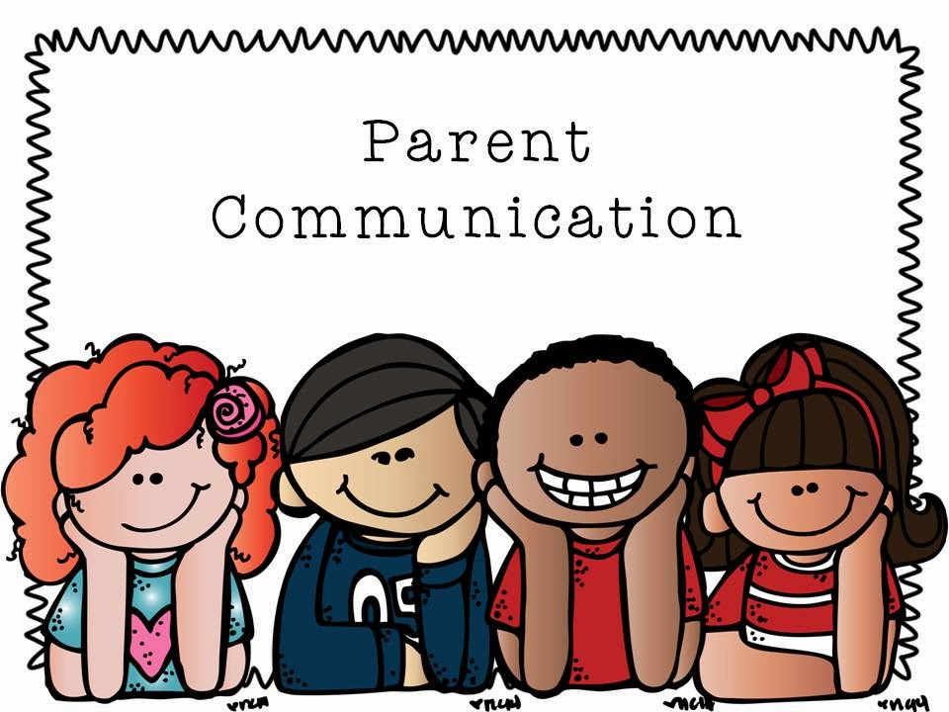 |  |  | 1  Happy New Year | 2  No School | 3  No School | 4
5 | 6  Staff Development Day No Students | 7  Collaborative Planning All Grade Levels 9:00am-  3:00pm  Room 120 | 8  Homework Help Parent Workshop  10:00am  &  1:00pm Room 110 | 9  Dr. Karen Mapp Training  8:00am-4:00pm PLC  PFRC Closed | 10  Parent Lending Library Room 110  Resources Available  8:30am-4:00pm | 11
12 | 13  Building Staff Capacity  (All Staff)  9am-3:00 Room 120 | 14  Homework Help Parent Workshop  1:00pm &  2:00pm Room 110 | 15  CCPS 101 Parent Workshop  11:00am &  2:00pm Room 110 | 16  Everyday Tools to assist your child in math parent workshop  10:00am &  2:00pm Room 110 | 17  Parent Portal Assistance 8:30-4 | 18
19 | 20  No School | 21  Math Matters Parent Workshop  4:00pm Room 110 | 22  The Roadmap To Understanding Common Core Workshop  11:00am &  2:30pm Room 110 | 23  CCPS 101 Parent Workshop  12:00pm &  2:30pm Room 110 | 24  Parent Portal Assistance 8:30-4  Room 110 | 25
26 | 27  Collaborative Planning All Grade Levels 9:00am-3:00pm Room 120 | 28  Parents as Leaders Workshop  11:00am &  2:00pm  Room 110 | 29  How to check your child’s progress  10:00am &  1:30pm  Room 110 | 30  Building Parent &Teacher Relationships Parent Workshop  10:00pm & 1:00pm | 31  Parent Lending Library Room 110  Resources Available  8:30am-4:00pm | 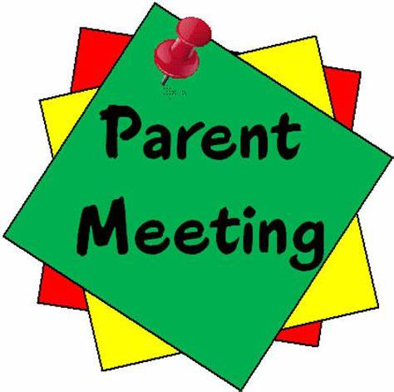
January 2020
Parent & Family Engagement Calendar

Pointe South Middle School
8495 Thomas Rd. Jonesboro Ga. 30236
Taji Givens-McCall Parent Liaison
770-473-2890 Ext. 520123 Room 110

